
STEPPING
STONES
COLLEGE

STEPPING STONES COLLEGE

2022
Families in Care
Registered Charity Number 1007596  www.familiesincare.co.uk |  | 


Families in Care

Established by birth parents in 1986,
Families in Care has been a registered
charity since 1992 and now we are
firmly recognised as a professional
organisation by the Judiciary and
Child Care professionals across Tyneside.
Emerging out of parents' own identified needs, from the very beginning Families in Care has
been placing families at the heart of its work. Creating a service delivery model that is
nurturing, non-judgemental, holistic and, most importantly, in partnership with birth parents,
we have drawn from the expertise of parents, practitioners and others coming into contact with
us in a variety of roles – social workers, solicitors, counsellors, academic lecturers. Over the
years we have developed a unique service, providing free specialist advocacy, counselling,
wellbeing and education for birth parents and high quality training opportunities for law and
social work students at all levels. Most importantly, we have created a safe space and a thriving
community, a constantly growing family consisting of people genuinely caring for each other,
positively contributing to each other’s lives and making the world a little bit kinder - one step
at the time.
“I feel at home here. It’s my family.”
(Linda, Families in Care Parent Mentor)


The Parents

For a parent at risk of losing their child, the experience of going through the safeguarding process can be bewildering, unfathomable, lonely and traumatic. The stakes are high and the power balance is often strongly weighted against them. Birth parents often lack knowledge and understanding of the process. They also have little emotional support, so it is not surprising that stress and anxiety levels are often high.

Despite these challenges the parents have much to offer each other as well as the wider aims of the charity, and as a direct result experience many benefits themselves. Throughout the years, the parents have developed their own support system and have regularly contributed to the education of others. With the support of a dedicated team consisting of experienced social workers, a professionally qualified counsellor, committed volunteers and trainee advocates, the parents have established wellbeing support groups and developed peer mentoring programmes. Their regular training sessions for local universities and service providers are recognised for their excellence and uniqueness.
“I thought it was only me, going through this nightmare, being without my children. Until I met the other mothers in Families in Care. Now I know I’m not alone, I can just offload and be myself.”
(Maura, Families in Care
Peer Support Group Member )

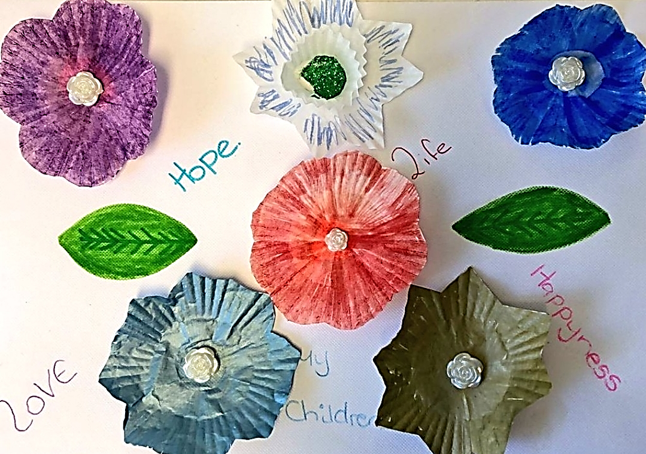
Learning and Development

Having parents at the heart of the service and recognising their potential, over the years Families in Care established the Training Team consisting of birth parents, social work students and a social worker coming together on a weekly basis to learn about matters related to family life, human development and social work practice. With the support of the Tudor Trust, those regular sessions developed into a rolling programme of weekly learning with mutually agreed themes such as parental mental health, social work assessments, managing stress or confidence building – and so many more!

The sessions received overwhelmingly positive feedback. Parents said that they had noticed increase of their awareness of social work policy and practice, as well as huge boost of confidence, self-esteem and positive feelings of being involved in something so meaningful i.e. the education of future social workers. Parents said the sessions were inspiring and motivating, encouraging them to consider a return to education and employment. Students described the sessions as eye opening, helping them gain a greater understanding of the complexities facing birth parents at a time when they are undergoing professional assessment and court hearings. Student’s values were challenged by the content of the sessions as they question their assumptions about working with parents involved in safeguarding process. Both sides reported gaining an insight into each other perspective and experience, and leaving the sessions enriched, more reflective and mindful of the significance of healthy curiosity, kindness and willingness not only to listen, but most importantly – to hear.

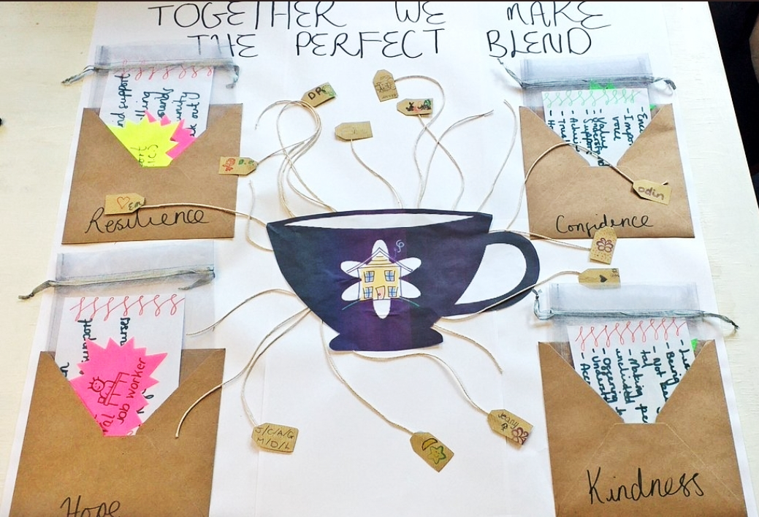
“Invaluable, eye opening experience.”
(Manda, Families in Care Social Work Student)
“Challenging and unique, you will not find this kind of opportunity anywhere else. I’ll never forget it.”
(James, Families in Care Social Work Student)
“”


Stepping Stones College
Given the outstanding success of the
programme, Families in Care Training Team,
together with the generosity of the Tudor Trust
have now established Stepping Stones
College, a training unit offering birth parents
and social work students an opportunity to learn and develop in a truly meaningful and
unique way. Between October 2021 and July 2022, every Friday during term time, our
enthusiastic team has been meeting up, learning together about matters important to us – in
a more structured way than before. The learning material has been grouped into themes of
wellbeing, social work practice, public speaking and peer mentoring. Educational sessions
were followed by Reflective College discussions.
At the end of the year four parents who have completed full training have prepared and
facilitated their own individual sessions for the group. The topics included Safeguarding,
Mental Health in African and Bangladeshi Cultures, DBT – Background and Principles of the
Therapy, and Storytelling – Use of Narrative in Social Work Practice with Families.
Those four parents, Joly, Cara, Linda and Helen, have now become the first Stepping Stones
Parent Facilitators. From October 2022 they will be playing a very important role in the further
development of the College – its next stepping stone - by implementing its programme and
contributing to the education and development of other parents accessing Families in Care
support, as well as a new cohort of social work students undertaking their practice
placement opportunities.

STEPPING STONES COLLEGE 2022: ACHIEVEMENTS  Weekly Learning and Development Sessions  Themes: Wellbeing and growth; Public Speaking; Peer Mentoring; Social Work Practice; Parent Learners’ Individual Sessions on Chosen Topics.  Weekly Reflective College Sessions  Weekly Reflective College Sessions were great opportunity to discuss learning, new ideas and difficulties encountered.  Wellness Recovery Action Plan  Parent Learners and Social Work Students have drawn their own individual WRAPs and have undertaken group sessions on WRAP history and principles. |   Peer Mentoring  Parent Learners have completed Peer Mentoring Tester sessions and some of them have now put themselves forward to complete full programme.  Public Speaking  All participants of the College have completed short Public Speaking course, which led to some of the parents expressing interest in training as group facilitators.  Stepping Stones College Parent Facilitators  Four Parent Learners have now graduated becoming first College Facilitators.  Learning Material  The team have developed Stepping Stones College Learning Material and Portfolio, containing all necessary resources for new academic year 2022 / 2023.
“Every parent and every social work student should have this opportunity. It’s life changing.”
(Overall feedback from parents and social work students)

STEPPING STONES COLLEGE: THEMES AND TOPICS

Blocks (stepping stones) of courses delivered in academic year 2021 / 2022

- Wellbeing, Growth and Development:
- Confidence
- Identity
- Resilience
- Self-esteem
- Positive Affirmations
- Stress Management
- Grief and Loss
- Mental Health: Various Topics / Short Discussions

- Wellness Recovery Action Planning:
- History / Background
- Principles
- Essential Elements
- Developing Individual Plans

- Public Speaking:
- Public Speaking – Introduction
- Managing Stress
- Building Confidence
- Helpful Techniques

- Peer Mentoring
- Peer Mentoring - Introduction
- Communication Skills
- Trust and Confidentiality
- Safeguarding
- Principles and Value of Peer Mentoring
- Managing Stress – Helpful Strategies

- Individual Sessions:
- Safeguarding
- Mental Health in African Cultures
- Mental Health in Bangladeshi Culture
- Dialectical Behavioural Therapy (DBT) – Introduction
- Story Telling: Use of Narrative in Social Work Practice

- Social Work Practice:
- Values and Ethics in Social Work
- Building Relationship with Families and Individuals
- Domestic Violence and Abuse
- Re (discovering) Strengths
- Hope and Meaning Finding
- Identity
- Reflective College

